Simulating Sustainability through a One Health Lens: An application of predictive modeling to optimize land-use planning in support of southern African wildlife conservation and rural livestock keeping.

1. **Abstract**

A fundamental obstacle in African wildlife conservation is the dual-use nature of savanna landscapes. Large herbivores need swathes of varied habitat to sustain herds and long-distance migrations; pastoralists also need the land to support their livestock. Disease transfer from wild to domesticated animals adds complication: A single case of foot and mouth disease virus (FMD) in a cow can exclude entire regions from high-value international beef markets. Veterinary cordon fencing, aimed at separating livestock from wildlife, has traditionally mitigated the risk of FMD but has cut off wild animal sub-populations from critical intermingling. Although non-fence-based techniques to mitigate FMD risk (including vaccination and science-based beef processing) exist1, governments are still reluctant to de-fence for fear of losing international market confidence.

In this project, I will elucidate fence removal’s projected impacts on wildlife resources, using elephants in the Kavango-Zambezi Transfrontier Conservation Area (KAZA TFCA2) as a focal species. I will (1) develop a mechanistic, individual-based random walk movement model and test it on real elephant telemetry data, (2) use this model to simulate elephant movements under fence-removal scenarios, and (3) present results to government decision-makers in KAZA member states.

As ecotourism revenues have begun to rival those of pastoralism in KAZA, conservation of large herbivores that shape ecosystems and draw tourists is crucial. In keeping with the Cornell Atkinson One Health theme, this project will spotlight the sustainable benefits of optimizing land-use planning at the interface of wildlife, livestock, and human health and livelihoods.

1. **Introduction**

My PhD work at Duke University explores how the provisioning and seasonal flux of surface water can drive herbivore movement patterns in African savannas. I use hoofed mammal (*ungulate*) aerial censuses in the Kruger National Park, South Africa, to determine the drivers of antelope population decline and subsequent non-recovery from the 1990s to mid 2010s. I am also evaluating how seasonal fluxes in surface water affect elephant movements through Bwabwata National Park, Namibia. Both projects are retrospective in nature, seeking to understand the causes of past behavioral and ecological change rather than predict how proactive changes in land-use decisions may impact wildlife populations’ futures.

I thus propose to use predictive modeling to approach similar questions from a future-focused perspective. Namely, *How does a rapidly-changing landscape affect ungulate movements and behavior?* and *How will these behavioral changes eventually affect populations as a whole?* This fellowship provides an avenue to work in applied wildlife conservation and positively impact land-use management policies, a goal driving my career. In addition, working closely with WWF’s Dr. Robin Naidoo on mechanistic modelling will also provide an excellent opportunity to expand my network of potential future colleagues at a conservation-focused NGO. The mentorship of Professor Osofsky, deeply embedded in One Health and science policy in KAZA, will help to ensure that my work progresses along the continuum from science to policy and action. Finally, the Sustainability Leadership Program will provide a solid foundation for my career in applied wildlife conservation.

1. **Description of Proposed Project**

For wild animals, freedom of movement ensures resilience to climate change and maintains long-term genetic and ecological population viability. A small, spatially restricted population is more vulnerable to extreme climate events or disease outbreaks than a similar population with free, varied habitat access12. Wild ungulates in southern African savannas are a prime example, relying on highly connected and heterogeneous landscapes to make great seasonal migrations to greener pastures (*refugia*).

Transfrontier conservation areas (TFCAs) strive to connect these landscapes and wildlife management across country borders. The Kavango-Zambezi (KAZA) TFCA spans Angola, Botswana, Namibia, Zambia, and Zimbabwe, boasts the Okavango Delta and Mosi-oa Tunya (Victoria Falls), and hosts some of the last great wild migrations on the planet. KAZA also supports pastoralists across the landscape, who make their living raising livestock. Therefore, governments must balance the needs of both wild and domestic animals within the TFCA3.

Wild-animal diseases that infect farmers’ livestock can upset this balance by imperiling access to international beef markets. To prevent viruses like foot and mouth disease (FMD) from infecting cattle, veterinary fences across KAZA restrict contact between wild species (esp. buffalo, *Syncerus caffer*) and disease-prone livestock. The status quo limits both wildlife movements and the ability of pastoralists in wildlife-rich areas to sell their beef. Adoption of non-fence-dependent strategies (e.g., vaccination, quarantine, biosafety via beef processing1) can reduce the need for some cordon fencing, but governments are hesitant to remove fencing for fear of losing the confidence of high-value international markets4.

Southern African savannas had supported great migrations for millennia but animals in fenced areas now cannot reliably access dry season refugia. Many perish either from hunger or physical entanglement in fence wire4. Elephants especially will also “bunch up” against fencing, exacerbating pressures on human communities and local resources2,5. Additionally, ecotourism across KAZA is an increasingly important component of local economies. If these issues are not addressed, ecotourism will slow, stunting employment opportunities for thousands within and around the region. Governments that wish to benefit from KAZA’s natural resources must ensure that it serves as a heterogeneous, connected refuge for wildlife.

1. Objective & Methods

Balancing the well-being of wildlife *and* beef markets offers genuine hope for a resilient system, one underpinned by linkages between rural areas (the source of wildlife and livestock) with urban areas (the most significant tourism and beef markets). **My proposed two-year research project will directly link fencing to restricted freedom of movement for wild ungulates and will be invaluable to convincing government officials of the urgency of addressing this issue holistically.**

I will conduct this research with Cornell professor Dr. Steve Osofsky and WWF partner Dr. Robin Naidoo. First, I will mechanistically model how African savanna elephant (*Loxodonta africana*) currently move throughout KAZA; next, I will simulate future elephant movements under various veterinary fencing removal scenarios. These simulated future connectivity scenarios will focus the five KAZA partner states on the genuine threat posed by extensive fencing, while demonstrating the long-term value of restoring landscape connectivity for wildlife migrations.

**Stage I: Model** (Sept 2023-May 2024) investigates how elephants currently move about the landscape and how sub-populations intermingle. Building on Dr. Naidoo’s previous work on landscape resistance6 and the importance of water7 and fencing2 to elephant movements, I will develop a movement model that guides simulated elephant walkers across a landscape, then test these simulations against telemetry data to hone model parameters. This type of individual-based modeling builds from first principles of animal movement, relying on resource-use memory8 and social behavior9,10 to produce emergent home range and territoriality patterns, and is a technique that has been under-utilized in landscape connectivity literature.

**Stage II: Predictive Simulation** (June-Sept 2024) uses the mechanistic Stage I model to predict how elephants willuse the landscape under fence-removal scenarios (no change, partial removal, full removal). Questions include:

* *How much will connection increase between elephant sub-populations in different KAZA protected areas?*
* *How much will de-fencing relax elephant pressures on fence-line resources?*

**Stage III: Visualization** (Oct 2024-Mar 2025) **and Presentation** (Apr-Jun 2025) prepares and presents these findings to government decisionmakers in the five KAZA countries. Visualization is an incredibly important tool in communicating scientific findings to stakeholders; these animations will specifically contrast the current, restricted nature of KAZA to a series of possible future states, communicating the need for and impact of fence removal. This visualization of the relationships between fencing and elephant movements will be a strong message to government stakeholders on the urgency of the fencing problem.

1. Resources & Partnership

Because this project relies on existing elephant collar and remotely sensed landscape data, I will need computing cluster access (through the Cornell Center for Advanced Computing’s BioHPC Program) to run models (Stage I) and simulations (Stage II), as well as funding for travel to present results to stakeholders (Stage III).

Partnering with WWF will give access to the restricted elephant satellite-collar data on which this project rests. Moreover, Dr. Naidoo has spent years studying how landscape features and human interventions affect elephant movements and landscape usage. His knowledge of this specific system, the challenges of working with telemetry data, movement and landscape resistance modeling techniques, and working relationships with key KAZA elephant experts will be invaluable to the success of this project.

1. Significance

The people of KAZA rely largely on beef production and ecotourism. This project will enhance the scientific basis of animal health and fencing policy, and the trend towards livelihood diversification. It will also increase consumer awareness about genuinely ‘wildlife-friendly’ beef and help draw tourists to witness a return of natural migrations at a vast scale.

Without full connectivity, KAZA does not truly exist. Fencing restricts access to drought refugia and creates barriers in which animals can (and do) get entangled and die. In addition, while there is encouraging evidence that historic migrations can be recovered after obstacle removal11, the window for restoring KAZA migrations is closing fast; we must act now to restore this natural process before it is too late.

1. **Impact Statement**

In a land-use system driven by animal disease management concerns, this One Health project focuses on ensuring a balance between the needs of people, their livestock, and wildlife. We aim to convince government decision-makers in KAZA countries (Botswana, Namibia, Zambia, Zimbabwe, and Angola, **Figure 1**) of the real and present threat that continued veterinary cordon fencing poses to wildlife, thereby encouraging a shift away from fencing towards non-fenced management strategies such as vaccination and value-add beef processing.

Affecting large-scale management change requires both means and motivation. Dr. Osofsky’s work in veterinary policy engagement through the Animal & Human Health for the Environment And Development (AHEAD) Program has already provided the *means* for KAZA member states to shift away from fence-based disease management; this Cornell Atkinson-funded simulation project will provide the *motivation* for change. A powerful, succinct visualization of simulated future scenarios will convince stakeholders that not only is there a better, less intrusive way to manage disease risk, but that it is urgent and necessary to prevent further impacts on wildlife.

A co-creative partnership with the WWF is crucial to meeting these goals (**Figure 2**). Through Dr. Naidoo's contacts with KAZA wildlife conservationists, I have access to restricted elephant collar data; these data are carefully guarded due to elephants’ endangered status and the prevalence of poaching in the area. I am already using these data for my third dissertation chapter, an extension of my work with Dr. Naidoo and a team at Duke on the flux of seasonal waterholes across KAZA13. In addition, I can take advantage of Dr. Osofsky’s KAZA policy engagement through AHEAD and of WWF’s longstanding partnership with KAZA member states, ensuring that I can engage the right stakeholders with my results.

1. **Statement of contribution to diversity**

As a Duke graduate student, I have led several diversity, inclusion, and decolonization efforts. This past spring, I helped organize the People and Nature Symposium, an all-day series of lectures on the varied relationships between humans and nature, beyond Western-focused science. This fall, I attained funding to invite a scholar from NC State (Dr. Madhusudan Katti) to run a half-day workshop on *Decolonizing Ecology* for Duke biologists and ecologists. As a Cornell Atkinson scholar, I will bring a focus on broadening our understanding of what “ecological science” is and who can practice it.

My study of charismatic savanna mammals also puts me in an excellent position to conduct public outreach on ecology to a diverse array of young students. I have run several “Skype a Scientist” outreach sessions with elementary schoolers across North America. These children come from different racial, income, and religious backgrounds, yet all share an enthusiasm for and love of elephants and zebras. As a postdoc at Cornell, I will expand on this work with Cornell’s Graduate Student School Outreach Program (GRASSHOPPR), using my research experience to mentor elementary schoolers on a more individual basis.

Finally, while reading Spring 2020’s “Belonging at Cornell” employee survey, I learned that *two thirds* of transgender and nonbinary employees witnessed at least one instance of disparaging remarks from a colleague, compared to one third of cisgender employees. How many of these remarks may have been made in the presence of LGBTQIA+ students, perhaps convincing them that they don’t belong here? Inclusion is not just about *getting* a diverse workforce; it is upheld by *sustaining* one. As a member of Cornell’s LGBTQIA+ community, I hope to not only be a role model for students, but to organize queer inclusion and education initiatives at the Cornell Atkinson Center for Sustainability.

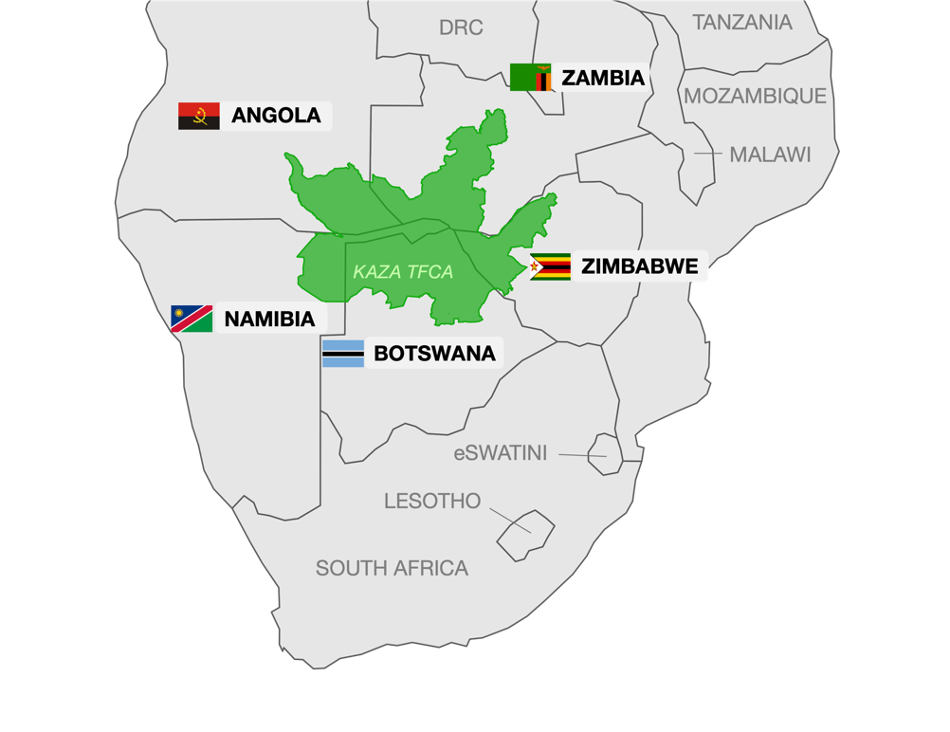

**Figure 1:** Kavango-Zambezi Transfrontier Conservation Area (KAZA TFCA) and member states.

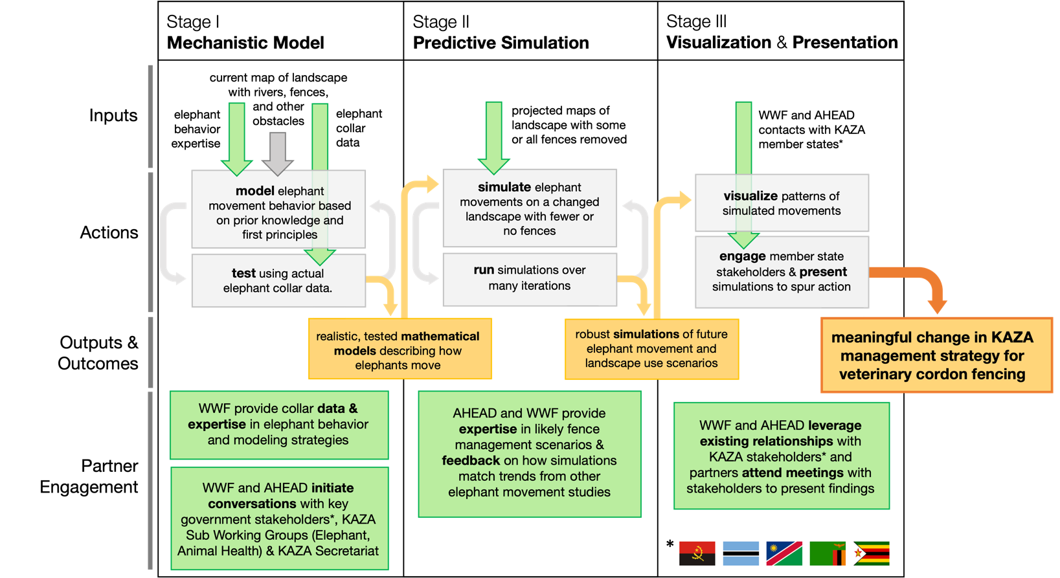

**Figure 2:** Co-creation engagement model outlining key project steps, inputs and outputs, and the accompanying partner engagement from WWF (Dr. Naidoo) and AHEAD (Dr. Osofsky). Green indicates key WWF and AHEAD partnership items; yellow, key project outputs; gray arrows, a cyclical process of model/test or simulate/iterate.

1. **References**

1. Thomson GR, Penrith M‐ L, Atkinson MW, et al. International Trade Standards for Commodities and Products Derived from Animals: The Need for a System that Integrates Food Safety and Animal Disease Risk Management. *Transboundary & Emerging Diseases*. 2013;60(6):507-515. doi:10.1111/tbed.12164

2. Naidoo R, Beytell P, Brennan A, et al. Challenges to Elephant Connectivity From Border Fences in the World’s Largest Transfrontier Conservation Area. *Front Conserv Sci*. 2022;3:788133. doi:10.3389/fcosc.2022.788133

3. Ferguson K, Hanks J. *Fencing Impacts: A Review of the Environmental, Social and Economic Impacts of Game and Veterinary Fencing in Africa with Particular Reference to the Great Limpopo and Kavango-Zambezi Transfrontier Conservation Areas.* Mammal Research Institute; 2010.

4. Thomson GR, Penrith M‐ L, Atkinson MW, Atkinson SJ, Cassidy D, Osofsky SA. Balancing Livestock Production and Wildlife Conservation in and around Southern Africa’s Transfrontier Conservation Areas. *Transboundary & Emerging Diseases*. 2013;60(6):492-506. doi:10.1111/tbed.12175

5. Loarie SR, Aarde RJV, Pimm SL. Fences and artificial water affect African savannah elephant movement patterns. *Biological Conservation*. 2009;142(12):3086-3098. doi:10.1016/j.biocon.2009.08.008

6. Naidoo R, Kilian JW, Du Preez P, et al. Evaluating the effectiveness of local- and regional-scale wildlife corridors using quantitative metrics of functional connectivity. *Biological Conservation*. 2018;217:96-103. doi:10.1016/j.biocon.2017.10.037

7. Naidoo R, Brennan A, Shapiro AC, et al. Mapping and assessing the impact of small-scale ephemeral water sources on wildlife in an African seasonal savannah. *Ecological Applications*. 2020;30(8):e02203. doi:10.1002/eap.2203

8. Van Moorter B, Visscher D, Benhamou S, Börger L, Boyce MS, Gaillard JM. Memory keeps you at home: a mechanistic model for home range emergence. *Oikos*. 2009;118(5):641-652. doi:10.1111/j.1600-0706.2008.17003.x

9. Jackson AL, Ruxton GD, Houston DC. The effect of social facilitation on foraging success in vultures: a modelling study. *Biol Lett*. 2008;4(3):311-313. doi:10.1098/rsbl.2008.0038

10.Carter N, Levin S, Barlow A, Grimm V. Modeling tiger population and territory dynamics using an agent-based approach. *Ecological Modelling*. 2015;312:347-362. doi:10.1016/j.ecolmodel.2015.06.008

11.Bartlam-Brooks HLA, Bonyongo MC, Harris S. Will reconnecting ecosystems allow long-distance mammal migrations to resume? A case study of a zebra Equus burchelli migration in Botswana. *Oryx*. 2011;45(2):210-216. doi:10.1017/S0030605310000414

12.Pickett, S.T.A. 1998. “Natural Processes”. In: M.J. Mac (Ed.), *Status and trends of the nation’s biological resources*, Reston VA. pp. 11-19.

13.Schaffer-Smith, D.S., M. Swift, A. Killea, A. Gamber, R. Naidoo, J.J. Swenson. "Tracking a blue wave of ephemeral water across arid southern Africa." *Environmental Research Letters*​(accepted 2022)

**Margaret Swift**

Nicholas School of the Environment margaret.swift@duke.edu

Duke University www.maggie.earth

Durham, NC 27708 github.com/margaret-swift

Education

2019 – **Duke University**,*Durham NC*

**Ph.D.** Environment, *in progress*

**Advisors:** James S. Clark, Susan Alberts

2013 – 2017 **The College of William & Mary**, *Williamsburg VA*

**B.S.** Computational and Applied Mathematics and Statistics, *magna cum laude*

Professional Positions

2019 – 2021 Teaching Assistant, **Duke University,** *Durham NC*

Assisted in teaching courses on Big Data, environmentalism, R programming,

data analysis, and Bayesian stats (see below). Developed classroom activities and converted in-person materials to virtual during the COVID-19 pandemic.

2017 – 2019 Developer, **International Business Machines (IBM)**, *Washington DC*

*Project: Food and Drug Administration (2018 – 2019)*

Created automated data management notifications; designed and developed a consolidated internal webpage for a data management toolkit.

*Project: Teva Pharmaceutical (2017 – 2018)*

Developed workflow automation tools to assist API testing; analyzed mock patient smart-inhaler datasets; worked as UI lead for patient user interface.

2015 – 2017 Research Assistant, **The College of William & Mary,** *Williamsburg VA*

*Project: Mathematical investigations of two-reef oyster system under Allee Effect*

Incorporated logistic growth, Allee effect, and dispersal into a deterministic analysis of marine populations; presented research at several math conferences.

*Project: Russian Movie Theater Project*

Conducted, transcribed, and translated Russian interviews; crafted user inter- face to assist researchers; analyzed topical trends and authored a web page.

Peer-Reviewed Publications

**Accepted**

Schaffer-Smith, D.S., **M. Swift,** A. Killea, A. Gamber, R. Naidoo, J.J. Swenson. "Tracking a blue wave of ephemeral water across arid southern Africa." *Environmental Research Letters.*

**2022**

Collins, C., S. Elmendorf, J.G. Smith, L. Shoemaker, M. Szojka, **M. Swift**, and K. Suding. "Global change re-structures alpine plant communities through interacting abiotic and biotic effects". *Ecology Letters* (2022). doi: [10.1111/ele.14060](https://doi.org/10.1111/ele.14060)

Qiu, T., R. Andrus, ... **M. Swift** ..., J.S. Clark.  Limits to reproduction and seed size-number trade-offs that shape forest dominance and future recovery. *Nat Comms* 13, 2381 (2022). doi: [10.1038/s41467-022-30037-9](https://doi.org/10.1038/s41467-022-30037-9)

Sharma, S., R. Andrus, ... **M. Swift** ..., J.S. Clark.  North American tree migration paced by climate in the West, lagging in the East. *PNAS* 119(3) e2116691118 (2022). doi: [10.1073/pnas.2116691118](http://doi.org/10.1073/pnas.2116691118)

​Journé, V., R. Andrus, ... **M. Swift**..., J.S. Clark.  Globally, tree fecundity exceeds productivity gradients. *Ecol Lett* 25(6) (2022). doi: [10.1111/ele.14012](http://doi.org/10.1111/ele.14012)

**2021**

Clark, J.S., R. Andrus, ... **M. Swift** ..., R. Zlotin. Continent-wide tree fecundity driven by indirect climate effects. *Nat Comms* 12, 1242 (2021). doi: [10.1038/s41467-020-20836-3](http://doi.org/10.1038/s41467-020-20836-3)

Qiu, T., M-C. Aravena, ... **M. Swift** ..., J.S. Clark.  Is there tree senescence? The fecundity evidence. *PNAS* 118(34) e2106130118 (2021). doi: [10.1073/pnas.2106130118](http://doi.org/10.1073/pnas.2106130118)

**2020**

Clark, J. S., C. L. Scher, and **M. Swift**. The emergent interactions that govern biodiversity change. *PNAS*, 202003852 (2020). doi: [10.1073/pnas.2003852117](https://doi.org/10.1073/pnas.2003852117)

Grants, Fellowships, & Awards

2021 Graduate Research Fellowship, **National Science Foundation**($138,000)

2020, 2022 Data Expeditions, **Duke University** ($5000 total)

2019 James B. Duke Fellowship, **Duke University** ($20,000)

2017 Post-Secondary Russian Scholar, **American Council of Teachers of Russian**

2015 EXTREEMS-QED Grant, **National Science Foundation**($4000)

Contributed Talks and Abstracts

2022 **Board of Visitors PhD Research Symposium,** *Duke Graduate School* (poster)

“Stronger together: How a network of seasonal waterholes unlocks animal movement across a dry African savanna”

**GRADx** *Duke Graduate School seminar* (TED-style public talk) Title as above.

2021 **Population Biology Seminar,** *departmental seminar* (talk)

“Diet-driven: How food and water availability influence population movement across two African savanna systems.”

2020 **Ecological Society of America Annual Meeting,** *virtual conference* (talk)

“Understanding the diverse responses of savanna communities to climate change”

2019 **Dynamic Species Distribution Modeling Workshop**, *Grenoble, France* (talk)

“Dynamic Generalized Joint Attribute Modeling (GJAM) Tutorial”

2019 **Mathematics Homecoming Alumni Panel**, *Williamsburg VA* (panel)

2016 **Joint Mathematics Meetings**, *Seattle, Washington* (talk)

“Dispersal-induced global extinction in a two-patch model under the Allee effect”

2015 **Young Mathematicians Conference**, *Columbus OH* (poster), *title as above*.

2015 **Shenandoah Undergrad. Math. & Stats.**, *Harrisonburg VA* (talk), *as above.*

Teaching Experience

2019 – 2021 Teaching Assistant, **Duke University,** *Durham NC*

*ENV 710: Applied Data Analysis for Environmental Science*

Wrote and taught lab material for two years in a statistical course for grad students. Focused primarily on environmental data, probability, regression, & statistical analysis in R. Prepared and implemented weekly lesson plans for computational labs and held extensive office hours. In 2020, adapted syllabus and materials to reflect COVID-19 virtual classroom changes.

*ENV 665: Bayesian Inference for Environmental Models*

Advised students in applying Bayesian inference and modeling (Gibbs sampling through JAGS, MCMC techniques) to their research projects.

*ENV 89S: Environmental Change in the Big-Data Era*

Led first-year students in discussion and debate over contemporary big-data

environmental issues; taught basic programming in R.

*ENV 832: Environmental Decision Analysis*

Taught decision analysis, lottery-weight systems, and decision trees.

2018 – 2019 Inventory Volunteer Team Lead,**Casey Trees,** *Washington DC*

2014 – 2017 High School Mathematics Tutor, **William & Mary***, Williamsburg VA*

Guest Lectures & Tutorials

2022 **Data Expeditions: Cleaning up Ellerbe Creek Data** *Duke University*

A lesson plan created for the Duke Bass Connections Ellerbe Creek Project with colleague Jonathan Behrens. Teaches data cleaning, exploratory data analysis, and challenges specific to messy field-collected data. *In prep.*

2021 **Data Expeditions: Do hurricanes affect bird biodiversity?** *Duke University*

A lesson plan created for the course “Big Data for Biodiversity and Climate Change” with colleague Lane Scher. Teaches linear modeling, exploratory data analysis, and challenges specific to Big Data. [*Rpubs*](https://rpubs.com/margaret-swift/eda-with-ebird)*,* [*GitHub*](https://github.com/margaret-swift/eBirdEDA)

2020 **Introduction to R** *Tutorial.*Three modules teaching basic R and RStudio. [*RPubs*](https://rpubs.com/margaret-swift/intro-to-r-01-orientation)

2020 **GJAMTime** *Tutorial*. Teaches [dynamic addition](https://www.rpubs.com/jimclark/631209) to the R package ‘gjam’ using data from the Kruger National Park, South Africa*.* [*GitHub*](https://github.com/margaret-swift/gjamTimeExample)

Academic Service

2020 – 2022 Ecology Seminar Co-Coordinator *Duke* *University Program in Ecology (UPE)*

2019 – 2020 Recruitment Committee, *Duke* *UPE*

2019 – 2020 Website Manager, *Duke* *UPE*

2019 – 2020 Resource Directory Developer, *Duke* *Graduate & Professional Student Council*

Diversity, Equity, and Inclusion Service

2022 Coordinator, *Decolonizing Ecology Workshop (Madhusudan Katti, NC State)*

2021 – 2022 Planning Committee, *People & Nature Symposium* [[site](https://ecology.duke.edu/people-and-nature-symposium/)]

2020 – 2022 Human History & Erasure Subgroup, *Unearthing Duke Forest Project* [[site](https://fhi.duke.edu/story-plus-project/unearthing-duke-forest)]

Professional Memberships

2021 – NSF Graduate Research Fellow

2019 – Society of Duke Fellows

2019 – 2021 Environmental Impact Fellow

2019 – 2020 oSTEM (Out in Science, Technology, Engineering, and Mathematics)

2016 – 2017 Dobro Slovo Slavic Honors Society

2015 – 2017 Pi Mu Epsilon Mathematics Honors Society

Relevant Coursework & Workshops

Ecology Field Skills in Plant Ecology (Kruger); Remote Sensing; LiDAR; Functional Ecology of Plants; Individuals to Communities; Animal Behavior; Population Ecology; Food Web Theory; Random Walks in Biology; Mathematical Biology

Statistics Theory of Statistical Inference; Bayesian Inference; Statistical Data Analysis; Probability; Computational Problem Solving; Data Structures; Ordinary Differential Equations; Partial D.E.’s; Nonlinear Dynamics & Chaos

Sci-Comm Challenge of Science Leadership (*Barefoot Thinking Company*); Science Communication

Certifications & Skills

Certifications SOLO Wilderness First Responder (~70 hours instruction, 2020);

CPR/First Aid Certification; PADI Open Water Diver

Computational R, Python, MATLAB, VBA, Bash, AppleScript, Mathematica

Geospatial Google Earth Engine, ArcGIS, ArcMap, ENVI

Web & Other Angular JS & 2+, HTML/CSS/JS, Apache NiFi, LaTeX, NLTK

Linguistic English, Russian, Spanish, French, American Sign Language